In the jenkins dashboard, click on manage jenkins then goto plugin manager and install

**TestNG Results plugin.**

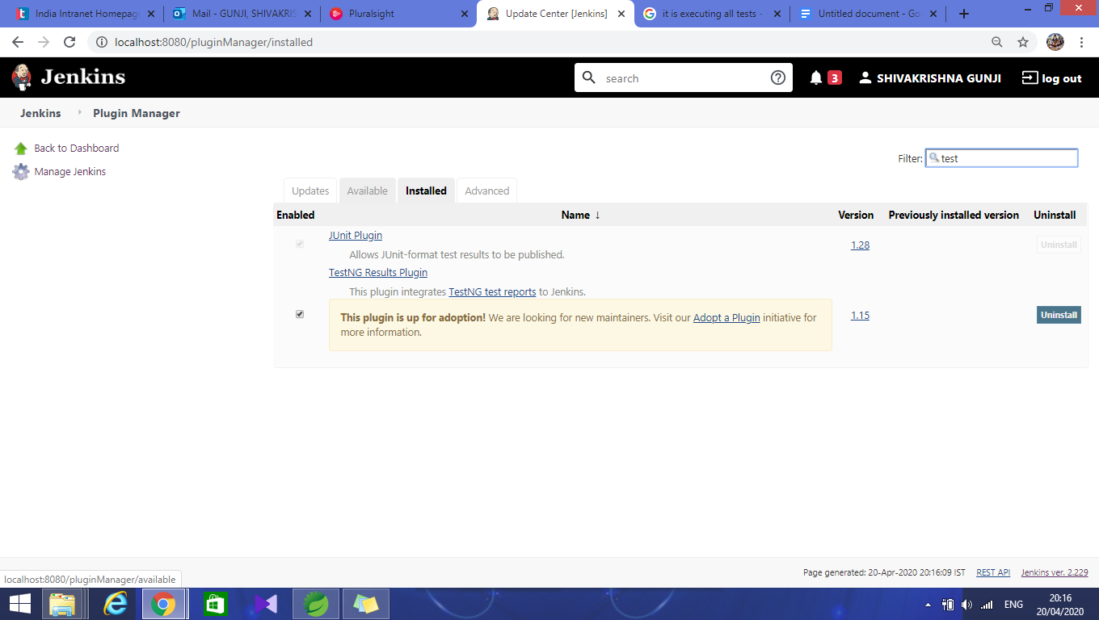

Next, create a jenkins job of freestyle type,

Next, in the general tab click on advanced button

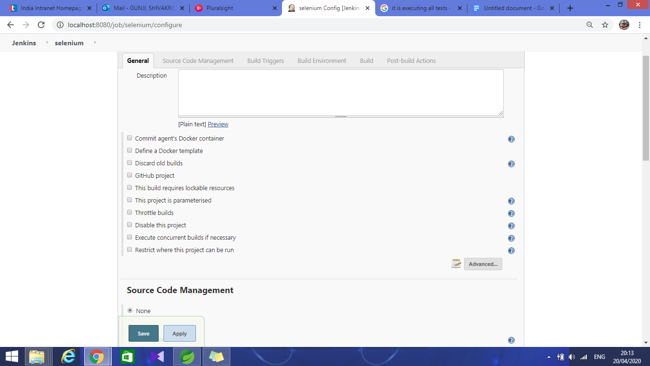

Then click on **use custom workspace** and enter the path of project.

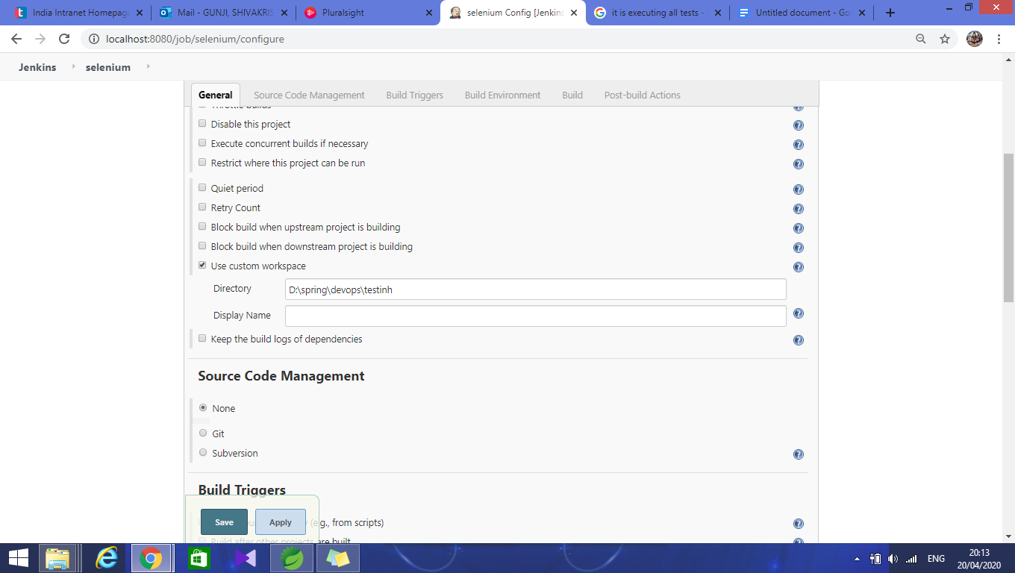

Next in the build section select **invoke top level maven project**

Then enter the **test** as goal as shown.

Then in post Build section select the **publish TestNG** Results as shown

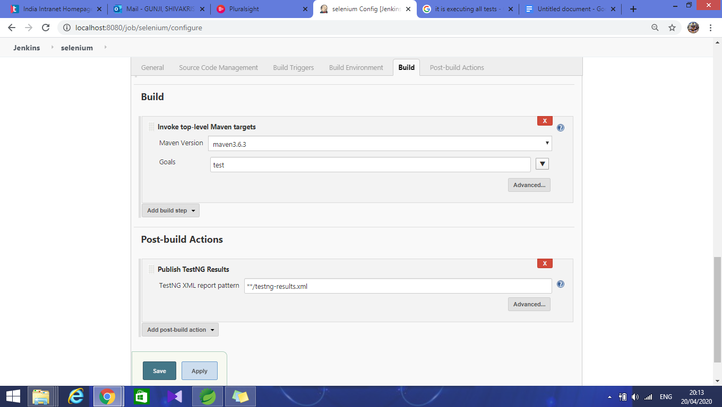

Click on **APPLY** and **Save.**

Click on **Build now in** jenkins dashboard.

And below is console output.

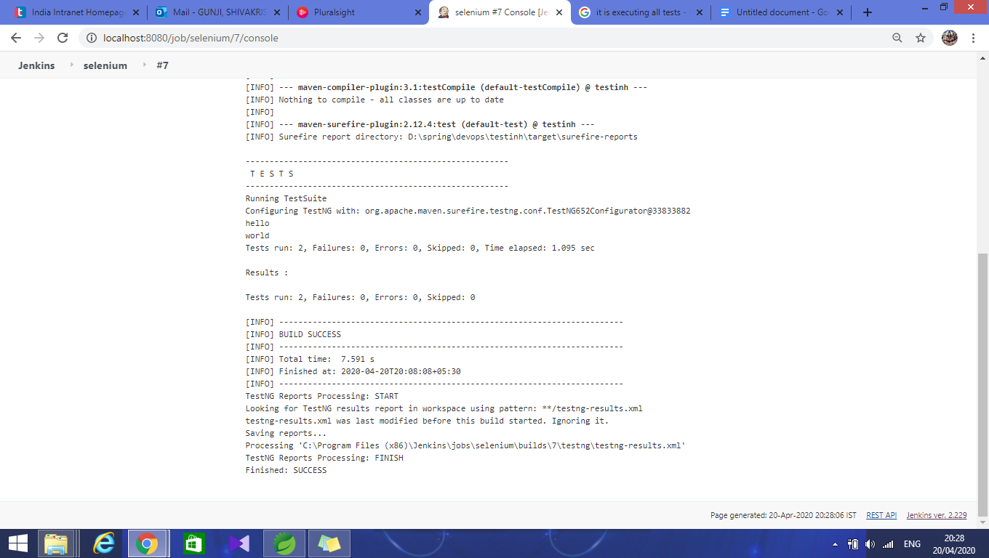

After successful build check the TestNG Results

